Question 1: Write a shell script that prints "Hello, World!" to the terminal.

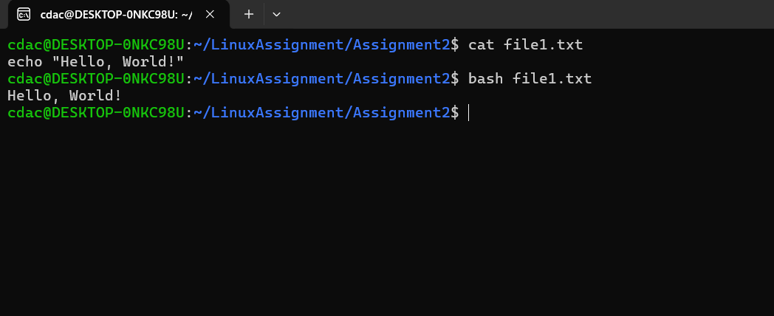

Question 2: Declare a variable named "name" and assign the value "CDAC Mumbai" to it. Print the value of the variable.

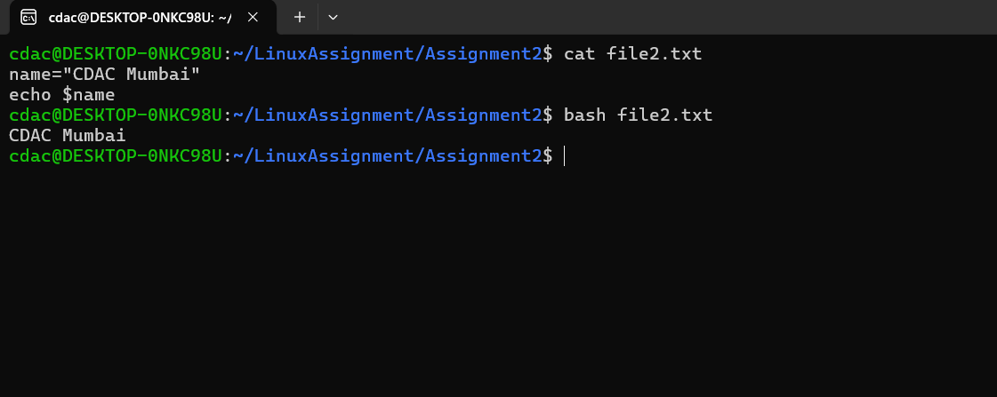

Question 3: Write a shell script that takes a number as input from the user and prints it.

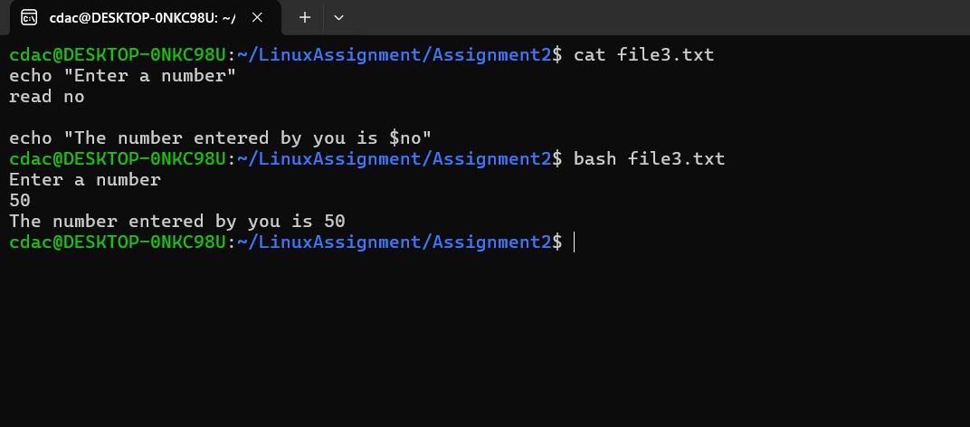

Question 4: Write a shell script that performs addition of two numbers (e.g., 5 and 3) and prints the result

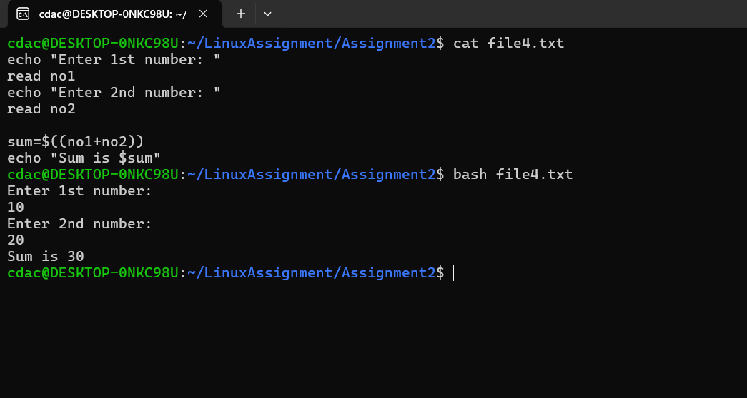

Question 5: Write a shell script that takes a number as input and prints "Even" if it is even, otherwise prints "Odd".

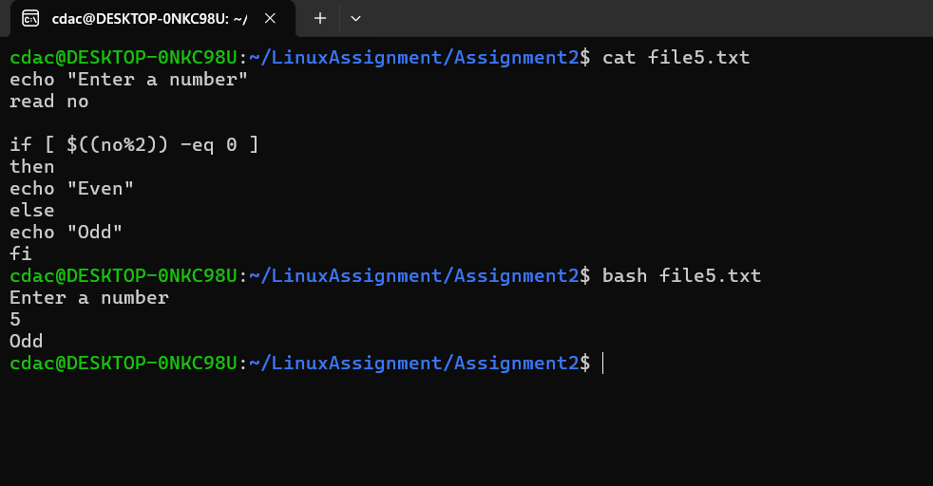

Question 6: Write a shell script that uses a for loop to print numbers from 1 to 5. Question

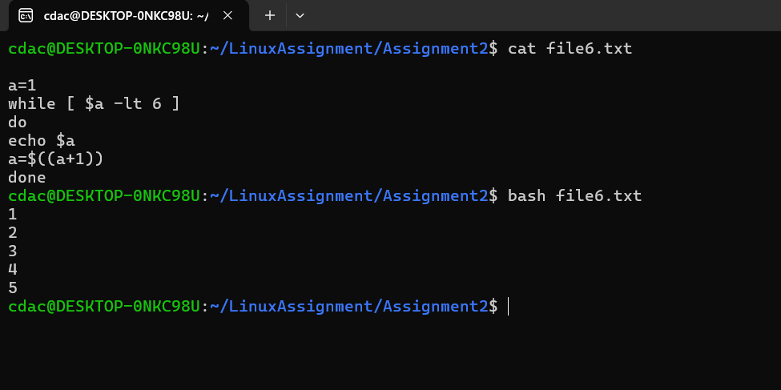

7: Write a shell script that uses a while loop to print numbers from 1 to 5. Question

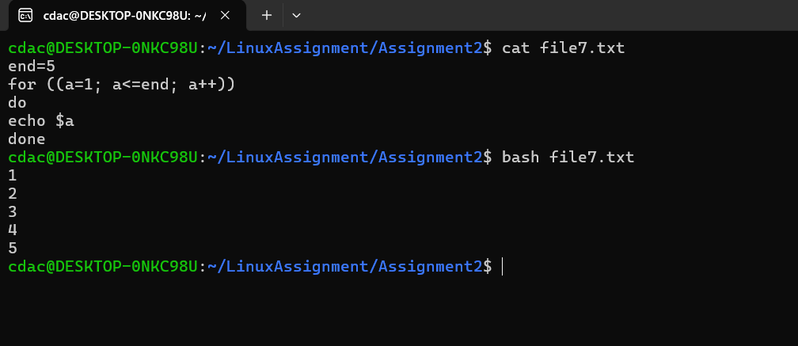

8: Write a shell script that checks if a file named "file.txt" exists in the current directory. If it does, print "File exists", otherwise, print "File does not exist".

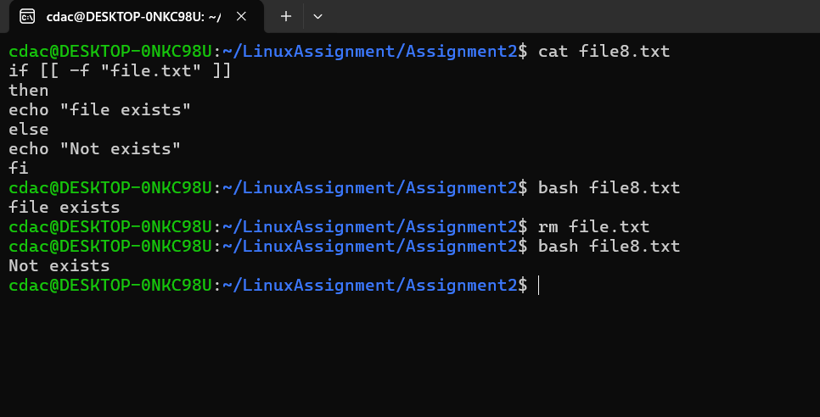

Question 9: Write a shell script that uses the if statement to check if a number is greater than 10 and prints a message accordingly.

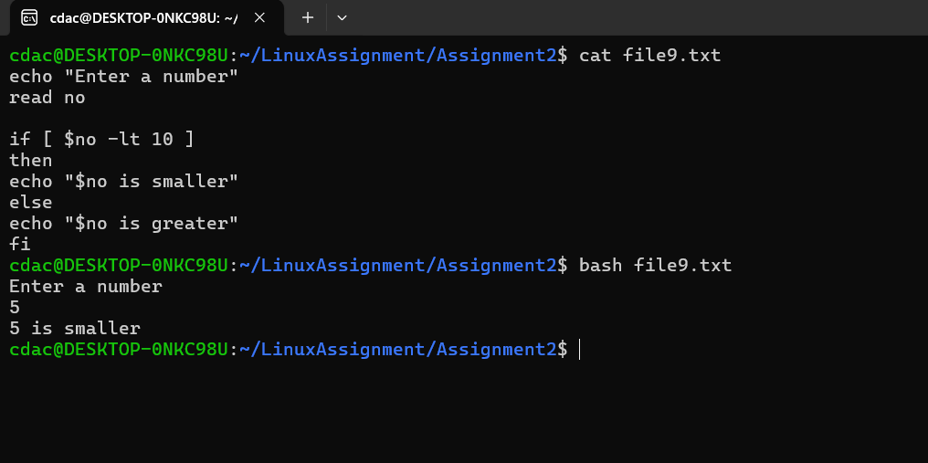

Question 10: Write a shell script that uses nested for loops to print a multiplication table for numbers from 1 to 5. The output should be formatted nicely, with each row representing a number and each column representing the multiplication result for that number

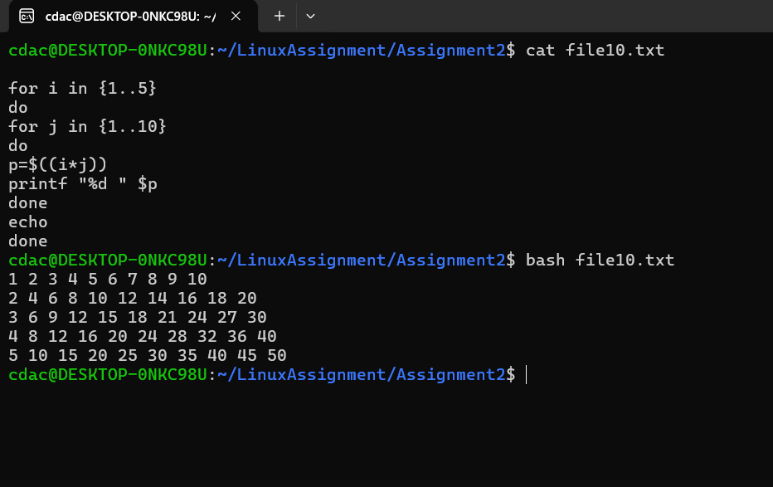

Question 11: Write a shell script that uses a while loop to read numbers from the user until the user enters a negative number. For each positive number entered, print its square. Use the break statement to exit the loop when a negative number is entered.

